|  |
| --- |
| LTU Billboard |
| Design Specification |
|  |
| Matthew Castaldini, Kathleen Napier, Ian Timmis, Hanan Jalnko |
|  |

Table of Contents

1 Introduction 3

1.1 Overview 3

1.2 Vision / Solution statement 3

2 Functional objectives 3

2.1 Organization 3

2.2 Student 3

2.3 Administrator 4

2.4 Guest 4

3 Technology Rationale 4

3.1 Frontend Technologies 4

3.2 Backend Technologies 4

3.3 Collaboration 5

4 Web Interface 5

4.1 Home Page 5

4.2 Login/Create Account Modal 6

4.3 Create Event Page 10

Event Page 10

4.4 Organization Page 10

Create Private Event Modal 10

Account Settings: 10

Create Event: 10

Organization Information: 10

Administration: 10

5 Technical Drawings 11

5.1 Database Schema 11

# 1 Introduction

## 1.1 Overview

The billboards in each building at LTU are the main place to acquire information of events on campus. There are many problems with this. Organizations do not always post on each billboard so students who may only go to select buildings will not see all of the events going on. Old posters rarely get removed so many students disregard the billboards in the first place. Many events do even post posters for their events and use some other sort of mean to getting there event recognized such as Facebook or face to face communication. The biggest problem however, is that students must be on campus to see any of this information.

## 1.2 Vision / Solution statement

Our vision is to create a website to facilitate the organization of extracurricular activities on campus by centralizing their agendas and allowing users to interact with those agendas in a unique yet intuitive way.

# 2 Functional objectives

## 2.1 Organization

Organizational features shall include

* Registering for an organization account
* Logging in as organization
* Create events and add to LTU Billboard calendar
* View event information
* View LTU Billboard calendar
* View organization information
* View announcements

## 2.2 Student

Student features shall include

* Register as student
* Log in as student
* View event information
* View LTU Billboard calendar
* View organization information
* RSPV for events
* Follow organizations
* View announcements

## 2.3 Administrator

Administrative features shall include

* Log in as administrative user
* Accept organization membership requests
* Deny organization membership requests
* Accept event requests submitted by organizations
* Deny event requests submitted by organizations
* Publish announcements to the home page

## 2.4 Guest

Guest features shall include

* View event information
* View LTU Billboard calendar
* View organization information
* View announcements

# 3 Technology Rationale

## 3.1 Frontend Technologies

The frontend technologies of LTU Billboard shall include HTML5, CSS utilizing the Bootstrap framework, and JavaScript utilizing JQuery framework with the FullCalendar plugin. HTML 5 shall be used to provide the information and structure of LTU Billboard as well as some form validation and session tracking. CSS shall provide the presentation layer and apply the formatting and style guidelines to LTU Billboard and the information provided by the HTML. Bootstrap shall be utilized with CSS to provide a more natural and standardized look for LTU Billboard as well as provide modal functionality. JavaScript shall be used to facilitate the client-side functionality of LTU Billboard. JQuery shall be used with JavaScript to provide form validation and allow the FullCalendar plugin to run inside LTU Billboard. The FullCalendar plugin shall be utilized to facilitate the display of events and organizations to the user in a natural way.

## 3.2 Backend Technologies

The backend technologies of LTU Billboard shall include PHP, MySQL and Apache. PHP shall act as the programming language used to create the interface required for the communication between the client and the server. MySQL shall be used to provide the web data store layer on the server. Apache shall be used as the software providing the web server.

## 3.3 Collaboration

The collaborative software used for LTU Billboard shall be GitHub, GIT and GroupMe. GitHub shall be used as the host for GIT repository. GIT shall be used to generate a repository and used for version/source control for the LTU Billboard project. The GroupMe smartphone application shall be used as the collaborative messaging application to communicate between the developers of the project.

# 4 Web Interface

## 4.1 Home Page

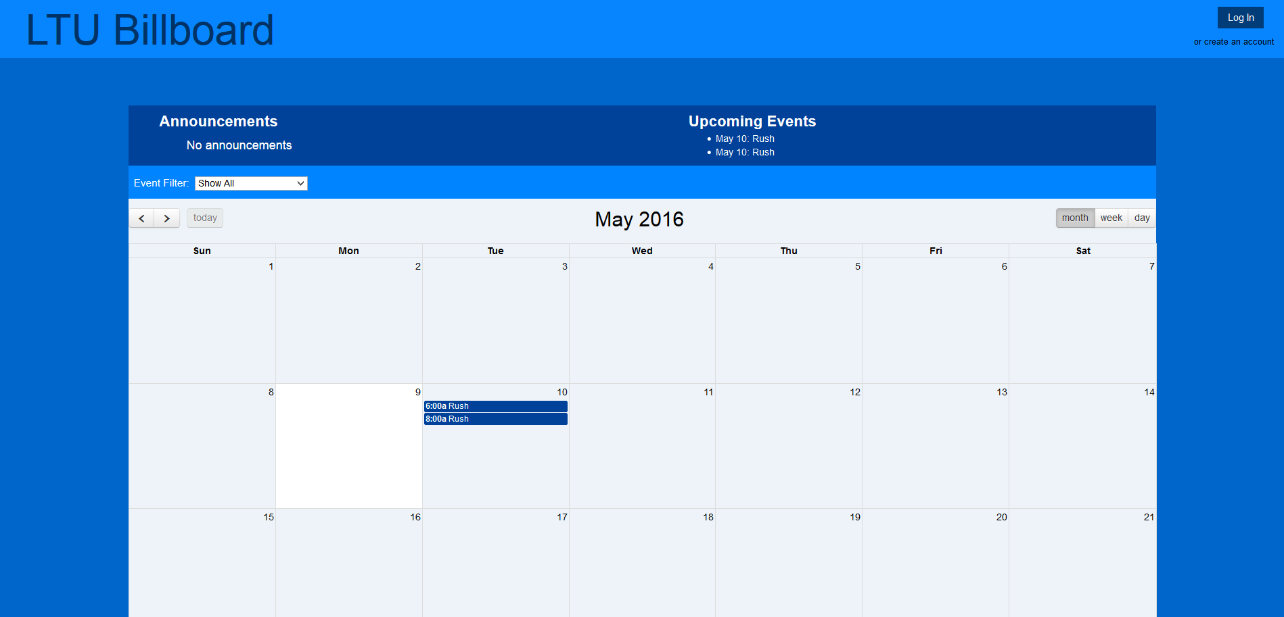

Home Page (Guest)

The home page contains the banner located at the top with LTU Billboard Logo, a login button and a register button. The login button and register button will open up the login/register modal described in section 4.2. The logo is hyperlinked to the home page so that while navigating the website, the user can easily return to the home page at any time. Underneath the banner we can see the notification banner along with the calendar. The upcoming events update to all the events that are shown on the calendar.



Home Page (Logged In)

Once the user is logged in, the banner shall update the label displaying that the user is logged in and provide a log out button to log back out of the account. If the user is logged in as an organization, the Create Event button is displayed which



Notification banner (Student)

While you are logged in to a student account you can add private events to the calendar as well. Once you press this button a modal will appear described by section

## 4.2 Login/Create Account Modal

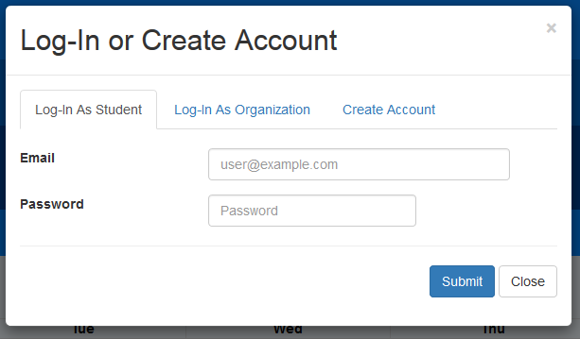

Login/Register Modal (Log-In as student)

This view allows the user to login as a student providing the email and password correlated with that users account in the database. Once logged in the user will no longer be labeled as a guest, but as a logged in student and will receive the permissions that students are given described in section 2.2.

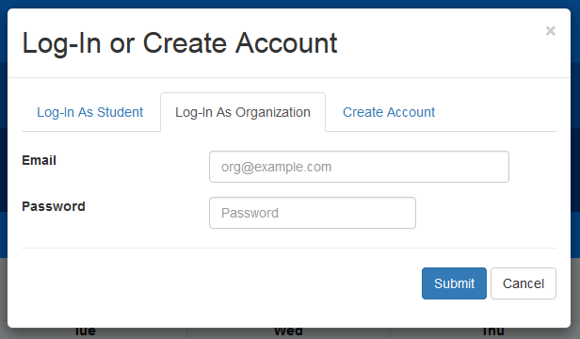

Login/Register Modal (Log-In as Organization)

This view allows the user to login as an organization providing the email and password correlated with that organizations account in the database. Once logged in the user will no longer be labeled as a guest, but as a logged in as an organization and will receive the permissions that organizations are given described in section 2.1.

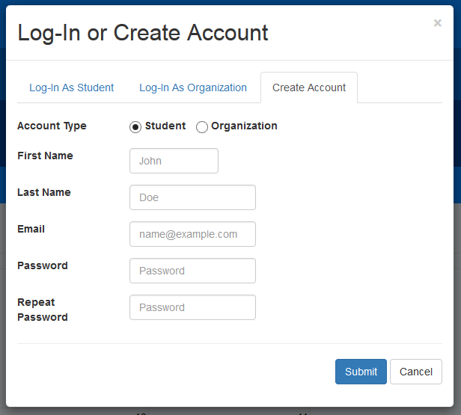

Login/Register Modal (Create Account - Student)

This view allows the guest to register an account with LTU Billboard with either the account type Student. The user needs to provide their own personal first name, last name, email and choose a password. The user shall repeat the password to ensure there is no mistakes. The submit button shall verify and validate the information in the modal and if everything checks out, create the student account in the database and allow the user to login as a student once returning to the web page.

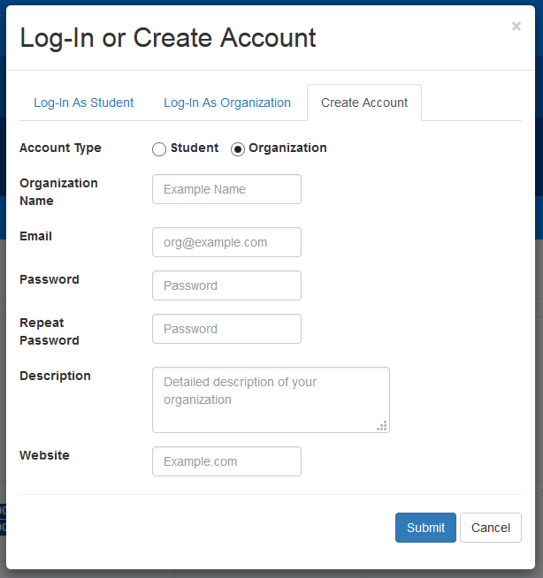

Login/Register Modal (Create Account - Organization)

This view allows the guest to register an account with LTU Billboard with either the account type Organization. The user needs to provide organization’s name, email, description of the organization and the organizations website. The users must also choose a password. The user shall repeat the password to ensure there is no mistakes. The submit button shall verify and validate the information in the modal and if everything checks out, create the organization account in the database and allow the user to login as an organization once returning to the web page. (Please note that an admin must approve of the organization request. However, organizations can still log on in the meantime.)

## 4.3 Create Event Page

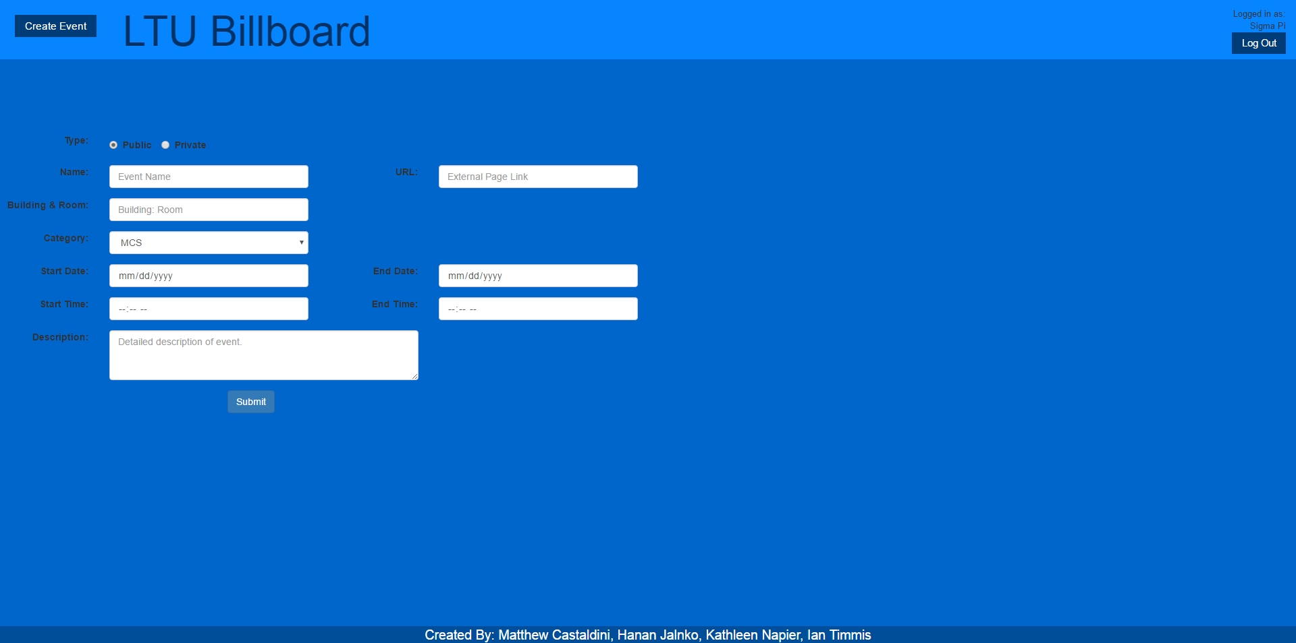

## Event Page

This page is used by organizations to create new events for students to view and RSVP to. The organization can select date and time for the event so that it can properly apply the event to the calendar. The website input shall be hyperlinked to from the event in the upcoming events section of the home page.

## 4.4 Organization Page

## 

Organization Page (Organization’s view)

This page when viewed by a user logged in as an organization allows the user to alter the information of the organization as well as view and delete the events scheduled for this organization. Also, the page will inform the organization if the organization is pending.

## 4.5 Private Event Modal

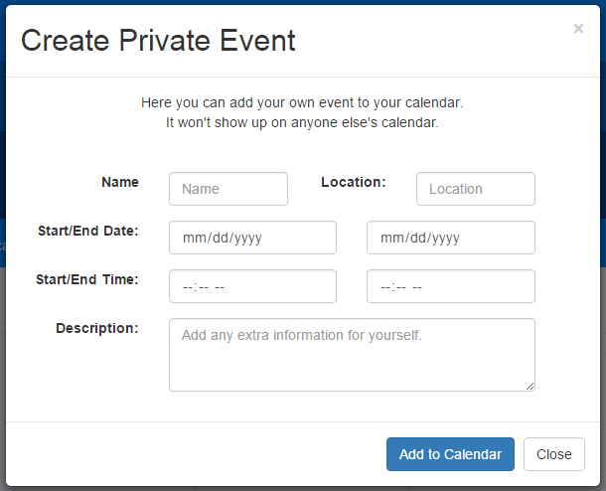

Private Event Modal

This view allows a student to create an event on the calendar for their self and add it to the calendar on the home page.

## 4.6 Administration Dashboard

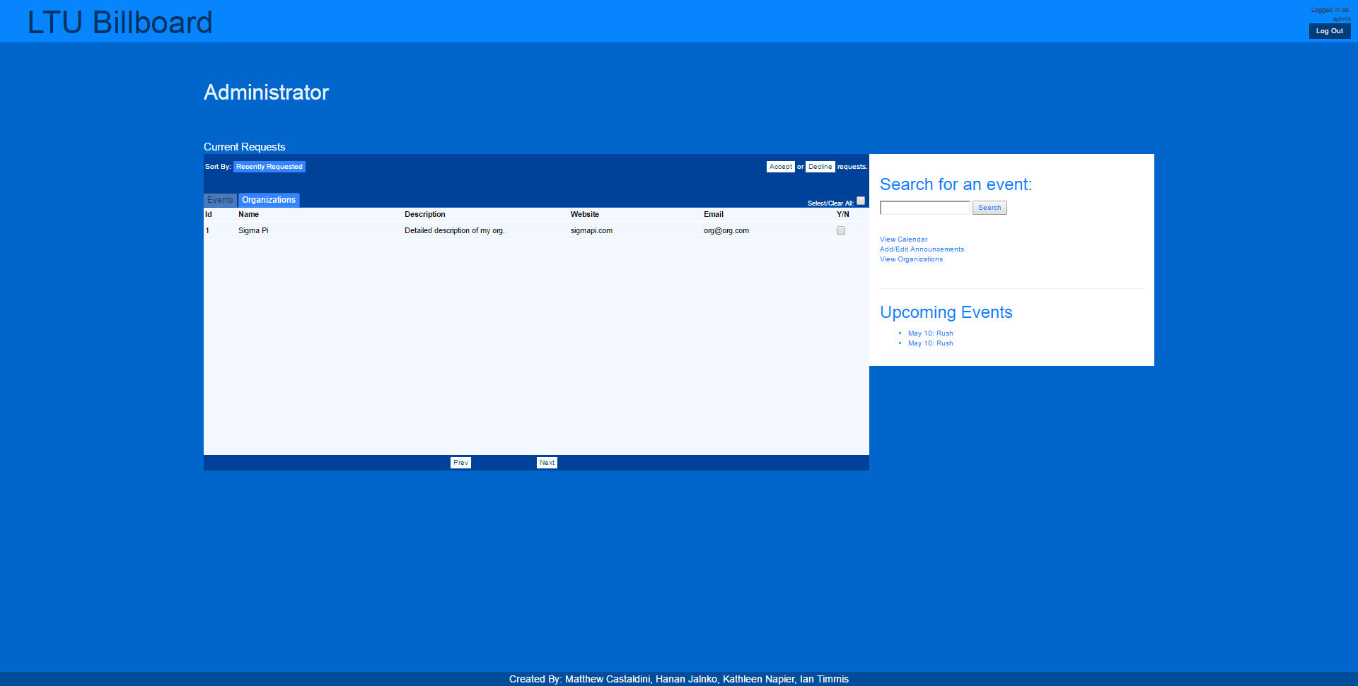

Admin Dashboard

This page allows administrators to accept or deny organization and event requests. There is also the ability to search for events and view upcoming events from this page.

## Account Settings:

# 5 Technical Drawings

## 5.1 Database Schema

